Ohio valley medical systems
ALTAIRE SERVICE MANUAL
OVMS
3/15/2013

Table of Contents

Software Procedures

Section 1 – Protocol and Service Backups 4

Section 2 – Characteristic Matrix 14
Acquiring 14

Section 3 – How to Run an SNR Scan 15

Section 4 – Altaire FOV Procedure 17

Section 5 – NVRAM 22
Troubleshooting NVRAM 22
Replacing NVRAM chip on AXI 23
Replacing NVRAM battery on Sun Blade 23
Reprogramming NVRAM 24
Section 6 – Database Reset 27

Section 7 – Changing Modality ID 28

Hardware Procedures

Section 1 – Replacing 1 PSI Valve 30

Section 2 – Replacing O2 Sensor 34

Section 3 – Transmitter Tuning 35

Appendix – Equipment Manuals
VIA Bravo 38
VIA Bravo Reset 38
Selecting Proper X and Y Axis Values 39
Radio Shack Autodialer(White) 40
Contents/Features 41
Installation 44
Set-up 47
Care 49
Specifications 50
Visonic Autodialer(Brown) 52
Introduction 52
Specs/Mounting/Wiring 53
Programing 54
Test 56
Appendix 56

Teledyne Model 3350 Oxygen Monitor 57

SOFTWARE PROCEDURES

Section 1 Software Procedures

PROTOCOL AND SERVICE BACKUP

Protocol and Service Backups serve the purpose of giving the Service Engineer the ability to easily and quickly re-instate the system settings. If changes are made to the system during the PM, or any other visit, having these two important backups can put the system back to its original settings, saving a lot of headache. These backups should be performed at the start of the visit, using the following procedures.

PROTOCOL BACKUP PROCEDURE

- Insert the Key Mod disc, and enter pass code. Remove Key Mod disc.
- Click the “Monitor” button on the upper right corner of the home screen. 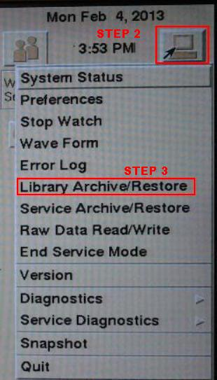
- Scroll down to “Library Archive/Restore” and click.
- Insert the Protocol Backup disc.
- Once the saved Protocols have shown up in the lower window, click “Initialize” in the lower right corner. 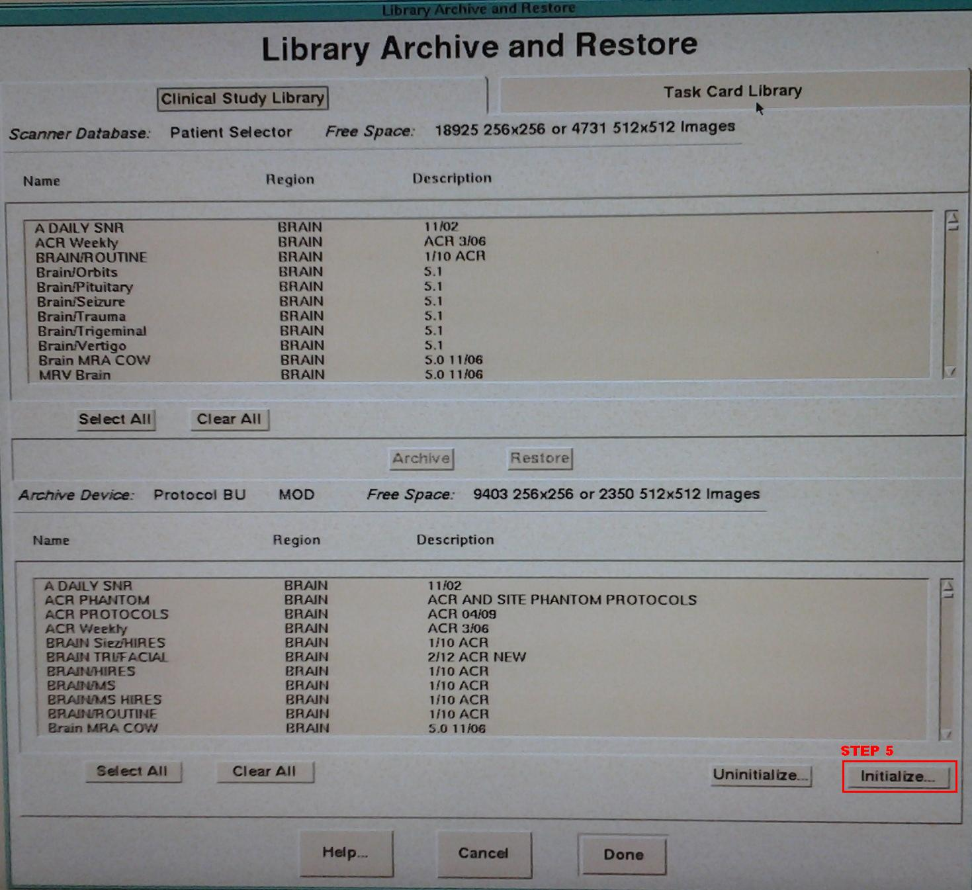
- A window warning you of the upcoming Initialize procedure will pop up: click OK to continue, CANCEL to stop the process. 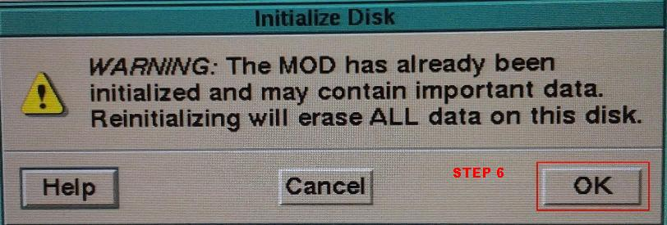
- After hitting OK to continue, a new window requesting a Volume label will appear. Enter a disc name, something like “Protocols (date)”. 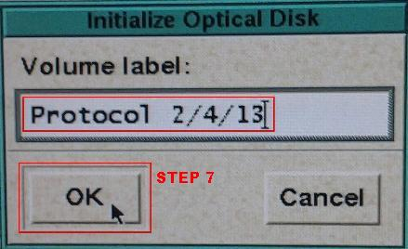
- One more window will pop up, to confirm you wish to proceed. Click “Yes”. 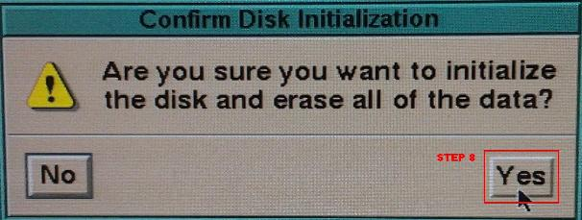
- Once the disc initializes, Click on the “Task Card Library” header at the top right of the window.
- Click “Select All” below the top list. All items in the list should now be highlighted in a darker brown color.
- Once all are highlighted, click “Archive”, located right below the highlighted files. 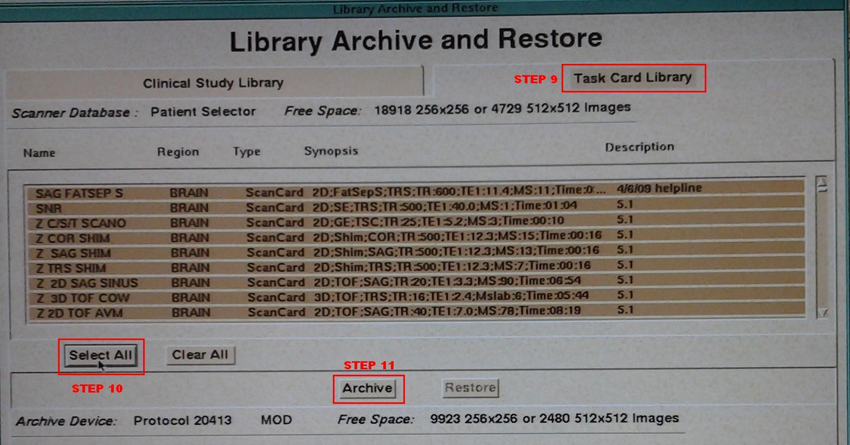
- Click on the “Clinical Study Library” header on the top left of the window.
- Again, click on “Select All” below the top list. All items in this list should also be highlighted a darker brown color now.
- Once all of these files are highlighted, click “Archive”, located right below these highlighted files. 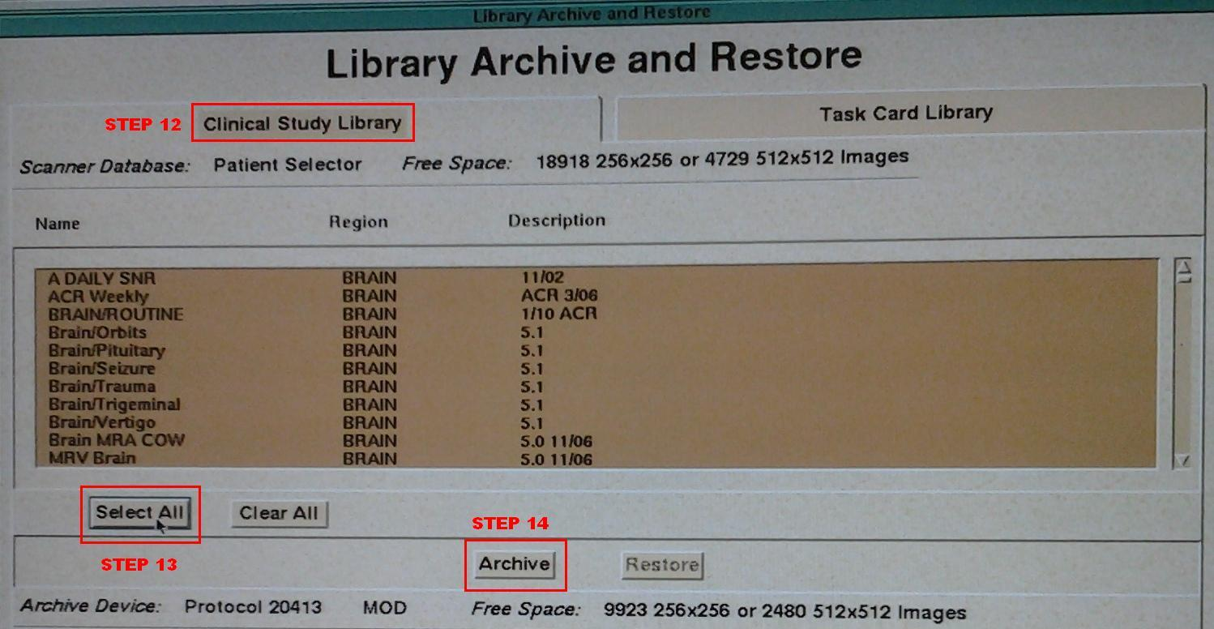
- Click on the bluish/green bar at the top of the window, and click/drag it to the left several inches, until you see the disc icon in the upper right of the home screen, now with a green dot on it. Click on that icon.
- You have now opened the “Archive Queue” and can now monitor the copying of the files you sent over for the Protocol Backup.
- You will have two groups on the bottom of the list, that are sending to the top. When both have been sent, they will reach 100%, and be removed from the lower screen. When all is done, exit this screen by hitting “Done”. 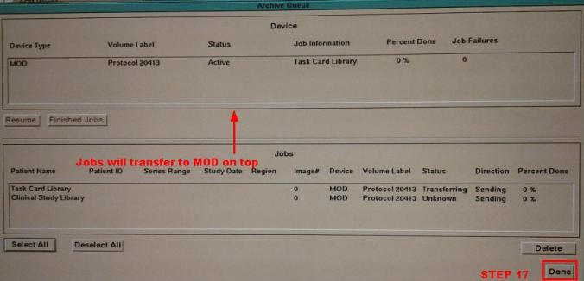
- Wait for the Protocol Backup to now load in the lower window of the “Library Archive/Restore” to verify complete, and you are done. Click “Done” to exit. Remove Protocol Backup Disc. 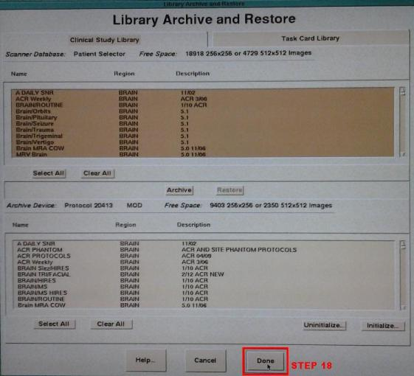
SERVICE BACKUP PROCEDURE

- Insert Key Mod disc, and enter pass code, if you haven’t already for the Protocol Backup procedure. If so, skip to step 2.
- Click on the “Monitor” button on the upper right corner of the home screen. 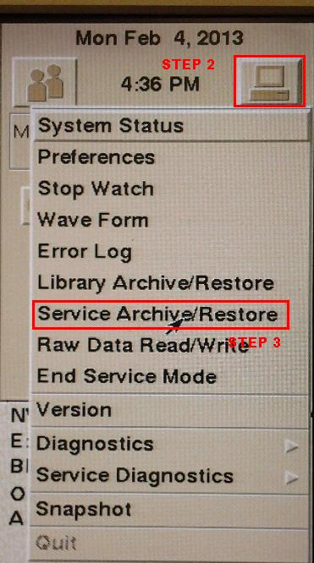
- Scroll down to “Service Archive/Restore” and click.
- Insert the Service Backup disc.
- Enter a new disc label.
- Initialize the disc by hitting the “Initialize” button. 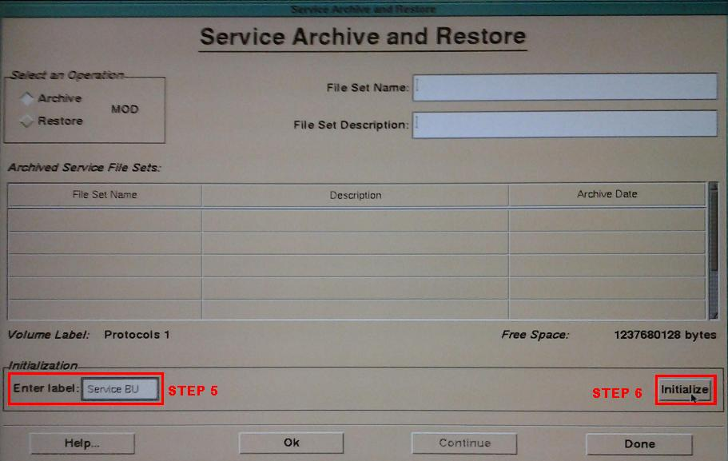
- Enter a new “File Set Name” and “File Set Description”. FSN should include the date of the visit, and FSD should show the purpose. In diagram the visit purpose was for a PM visit. 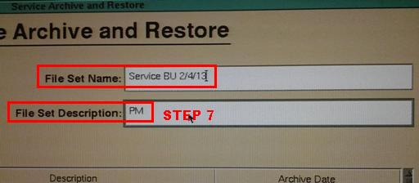
- When ready to perform the Backup, press the “OK” button at the bottom of the screen. 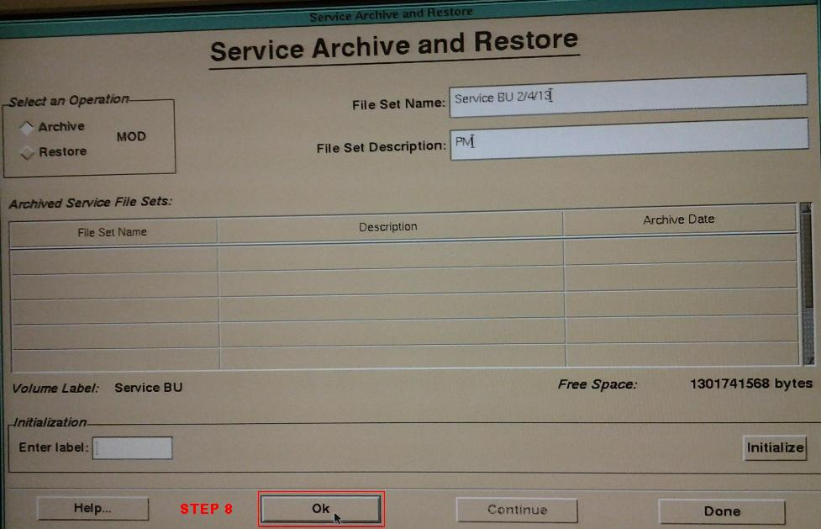
- After several moments, the Backup will complete, and the following window will appear. Click “Done”. 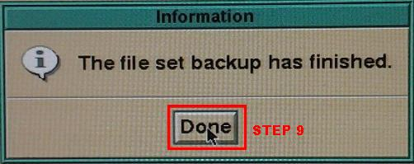
- You should now see the “File Set Name” and File Set Description” that you entered listed in the lower boxes.
- Click “Done” to complete the Service Backup and exit the screen. 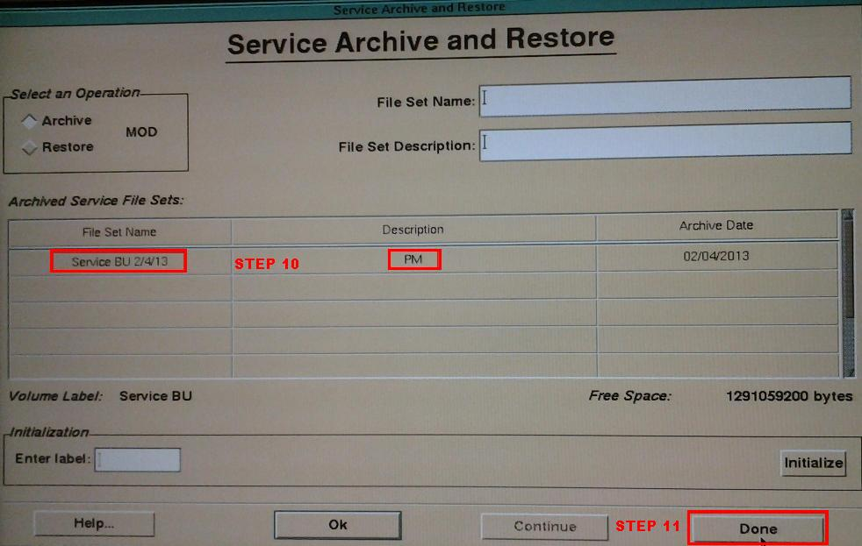

NOTES:

In both the Protocol and Service Backup procedures, it is possible to get a disc error when trying to Initialize the disc. If this occurs, the disc may very possibly be bad. Try a different disc.

Section 2 Software Procedures

ACQUIRING THE CHARACTERISTIC MATRIX

- Set the QD Flex coil Large and Sphere phantom large at the center of magnetic field. Use a Grid to center phantom perfectly.

2. Set Head View of System Status in the System Tool to BOTTOM (See Instruction Manual).

3. Set Scaled Window / Level of Viewing in the System Preference to Off (See Technical
Guide).

4. After using the key MOD to register T/M license (See Technical Guide), create the scan card to acquire a positioning image.

5. If not already created. Create a scan card for characteristic matrix measurement. To put it concretely, set the sequence name of Basic group to Shim and scan option to Matrix. If setting Window to 6 and Level to 500, images may be clearer.

6. Images are acquired for all planes. The following 7 types of images are acquired 15 frames each.
Reference images:
Z0 characteristic images
Z2 characteristic images
Z4 characteristic images
X1 characteristic images
Y1 characteristic images
Z1 characteristic images

7. Check if all characteristic images are correctly acquired. For example, the characteristic images on TRS axis are shown below. (Note that characteristic images shown below are typical ones and there may be small difference according to the system.)

8. When completing acquisition for all planes, return settings of Head View and Scaled Window / Level to original ones.

NOTE: Characteristic matrix measurement needs not to be performed every time. Perform in installation and periodical inspection, or when image quality problem occurs. Also characteristic matrix should be measured for all of 3 planes (TRS, SAG and COR). By measuring characteristic matrix for all of 3 planes, volume shimming is available on any plane. However, if image quality problem occurs in any specific plane only, characteristic matrix measurement may be performed only for that plane. There may be such case that the scan time displayed is different from the actual measurement time.

10. Repeat for all Planes.

Section 3 Software Procedures

HOW TO RUN AN SNR SCAN

NOT YET UPDATED AFTER SCOTT’S SUGGESTED CHANGES

Section 4 Software Procedures
ALTAIRE FOV PROCEDURE

FOV (Field of View) is how true an image looks on the screen to the real article, whether it be a Phantom, or a Patient Study. A Shim of the magnet sets the original parameters, but periodically, adjustments are necessary.

The Field Service Engineer can accomplish this by using a software program called “GC Gain Parameter Set”. The following will explain how to do this.

NOTE: Make no adjustments in the procedure without FIRST having done the Protocol and
Service Backup procedure.

- Insert your Key Mod disc, and enter the password.

2) Set up the Head Coil on the table, and install the FOV jig.

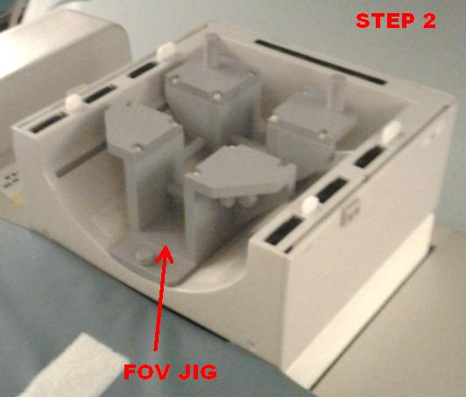

3) Align the FOV Phantom in the jig, using your laser indicators. (TRS shown in photo).

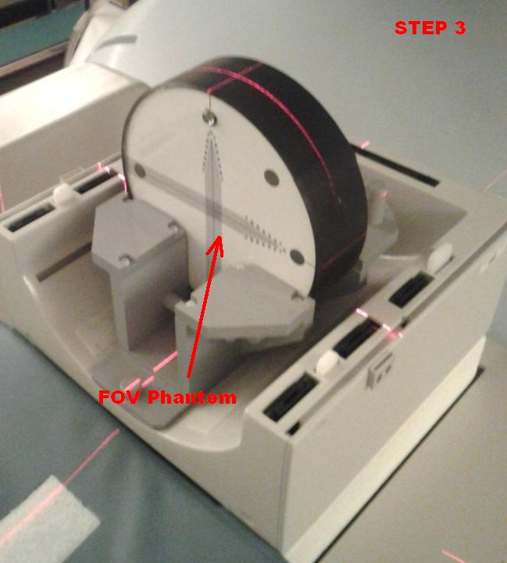

4) Using the “Set” button, send the Head Coil into the bore of the magnet.

5) Using normal Daily SNR Protocols, Change Scano to TRS, and run the SE Scanogram.

6) Tab to the SNR Scan, and on the Control Screen, click and drag the green
crosshair to the center dot on the FOV Phantom image.

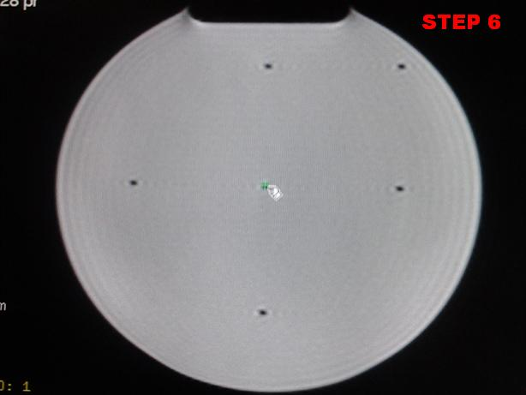

7) Run the SNR Scan.

8) Tab to the Maint card, and click on the FOV header at the bottom. You will see the 4 FOV measurement boxes around the 4 outer black dots on the image. If they are not, return to Step 3 and realign. If they are, click Start.

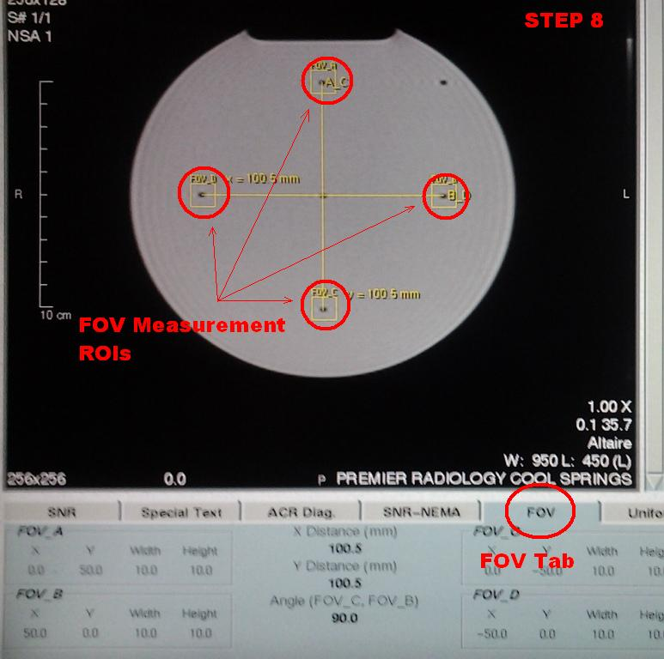

9) If readings for both planes are between 99.5 and 100.5, no adjustments are needed. Change your Phase direction on the SNR Card, under the Matrix tab, and run the other plane (Step 7).

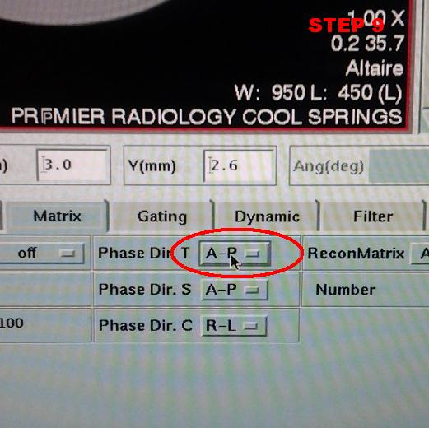

10) If adjustments are needed, click the Monitor icon at the upper right of the screen, then scroll down to Service Diagnostics, and click. Now click on T/M
Manager.

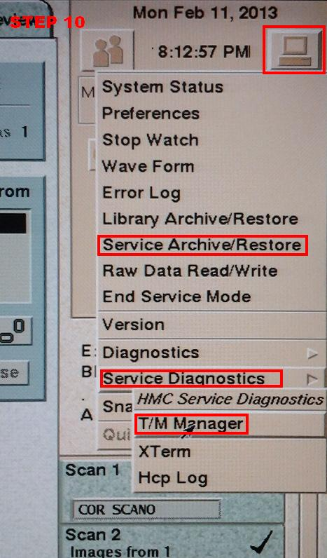

11) When the T/M Manager screen pops up, scroll down to “GC Gain Parameter Set”, and click it.

12) Select X, Y or Z axis to correspond with the change you wish to make. NOTE: The onscreen planes will always show X horizontally, and Y vertically, but remember, that your X plane is R-L, Y plane is H-F, and Z plane is A-P.

13) Enter the measured reading that you are changing in the “Measured” box, and hit ENTER.

14) Click SET on the bottom of the box to complete the adjustment.

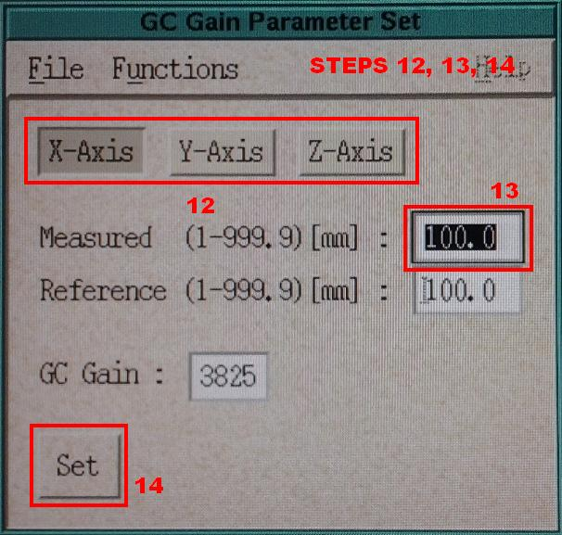

15) Click File on the top of the GC box, then click Quit. Click Yes to exit.

16) Repeat steps 7, 8 and 9 to verify the new value. If it is now in spec, change Phase direction as mentioned in Step 9, and go to Step 7.

17) Once both planes are done for the SE(Spin Echo) TRS, go back to the Scano Card, and the SNR Card, and change SE to GE(Gradient Echo).

18) Repeat Steps 5 through 8, and if adjustments are needed, follow with Steps 10 through 16.

19) Once all 4 Axial planes are done(R-L and A-P Phase for both SE and GE), run the Head Coil out of the Gantry, and switch to COR. Repeat Steps 3 through 18 for the COR adjustments.

20) Once all 4 COR planes are done(R-L and H-F Phase for both SE and GE), run the Head Coil out of the Gantry, and switch to SAG. Repeat Steps 3 though 18 for the SAG adjustments.

NOTES: If you find that you have made things worse, and made a mistake along the way,
insert your Service Backup Disc, and perform a System Restore. That will put you
back to square one, but you won’t have made things worse.

Section 5 Hardware Procedures

NVRAM

NVRAM is an acronym for non-volatile random access memory. Non-volatile means that it keeps its data even when power is removed from the system. It does this with a battery. It is used for storing basic setup information.

Troubleshooting NVRAM

When NVRAM is failing, the computer is not retaining the necessary settings that it needs. Though the default BIOS settings remain, the computer will not function correctly since the BIOS relies on the settings stored in NVRAM in order to handle the particular hardware and environment.

Check for missing data:

  - Boot system
  - At white screen press Stop-A
  - At ok prompt type banner
  - If the information stored in NVRAM is gone, the Ethernet MAC address will be ff:ff:ff:ff:ff:ff

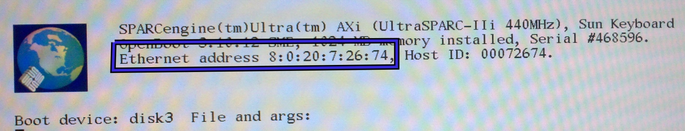

Another symptom of a bad NVRAM battery is a system clock that will not keep time when the system is powered down. If you see these indicators, it is likely that you should replace the NVRAM chip (AXI) or the NVRAM battery (Sun Blade).

Replacing a NVRAM chip on an AXI motherboard

- Turn system off.
- Remove old NVRAM chip.
- Insert new NVRAM chip.
- Program new NVRAM.
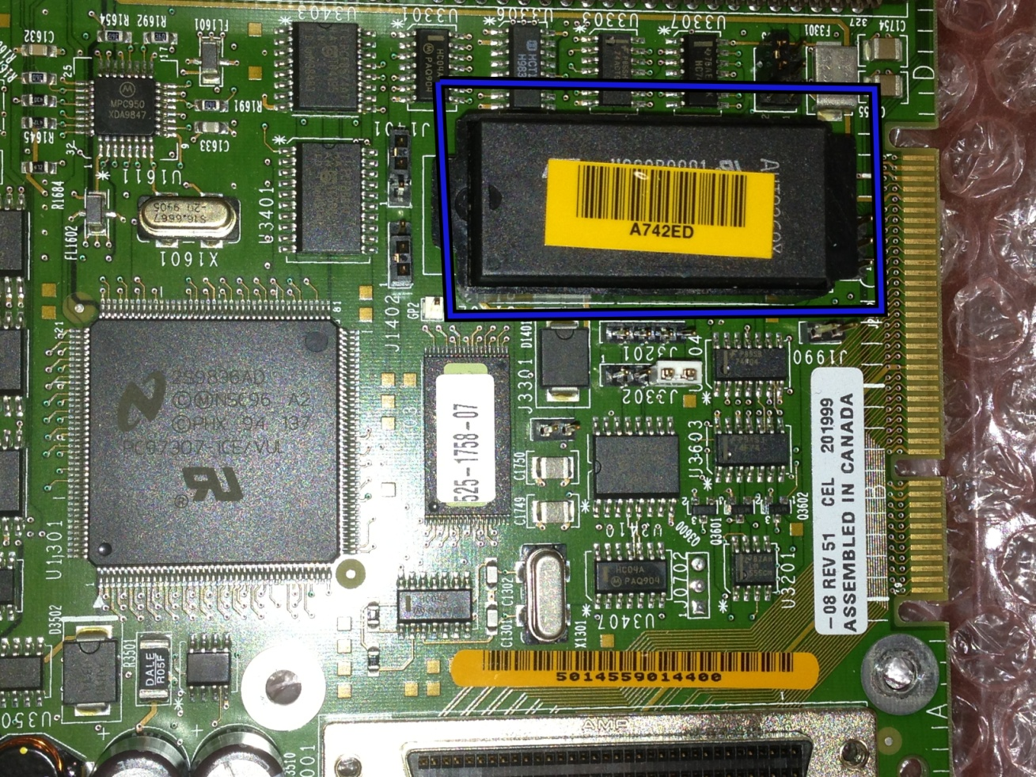
This is the NVRAM chip on the AXI mother board. This chip can be replaced.

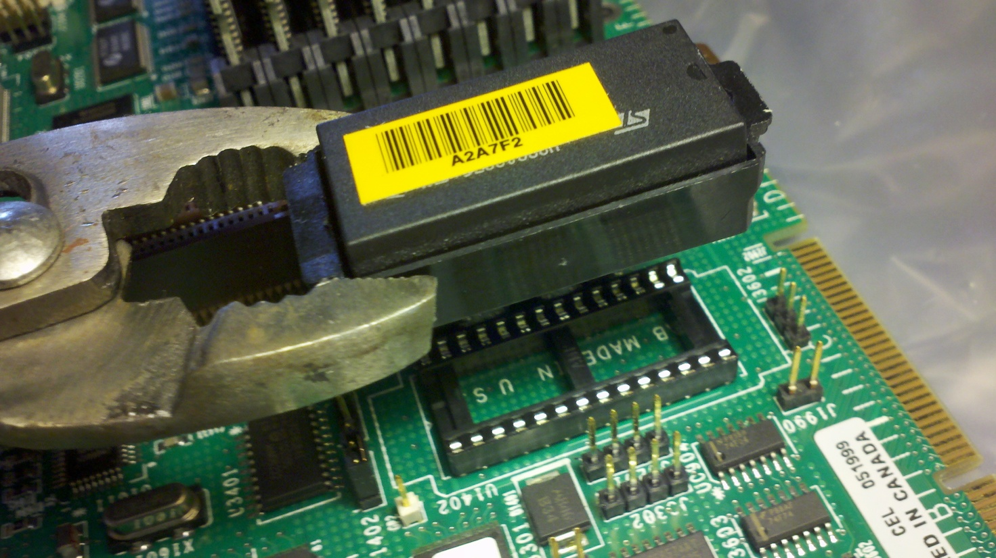
NVRAM chip in its caddy removed from the motherboard and the tool used to remove it.

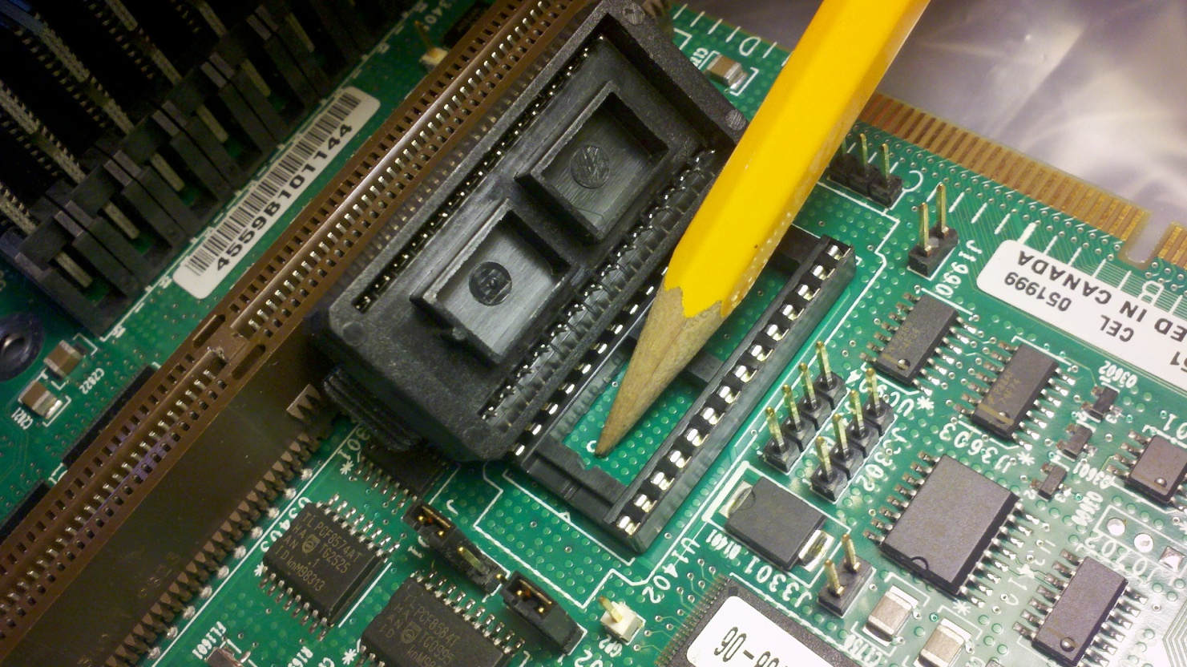
This is the underside of the NVRAM caddy beside the socket on the motherboard. Note the registration key and groove.

Replacing NVRAM battery on Sun Blade

- Turn system off.
- Replace the battery.
- Reprogram the NVRAM.
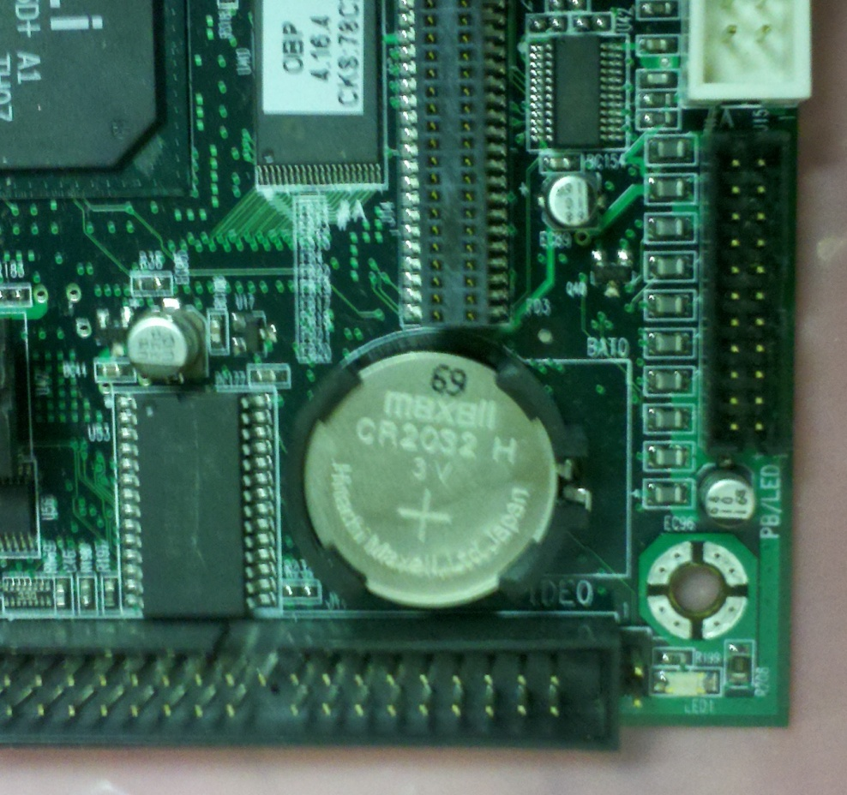

Sun Blade NVRAM battery in its holder

The Sun Blade motherboard has a coin size battery. This is what is used to keep the power on the NVRAM. It is a CR2032. Purchase at any store on planet earth. Stick the new one in the mother board. Do not break the flimsy battery holder on the motherboard.
Reprogram NVRAM.

Reprogramming NVRAM

- Boot system.
- At white Screen type: Stop –A
- At ok prompt type:
set-defaults
setenv output-device screen:r1280x1024x67
setenv boot-device disk3
setenv diag-switch? false
setenv use-nvramrc? true
setenv nvramrc devalias disk1 /pci@1f,0/pci@1/scsi@1,1/disk@1,0
To see and check your work type: printenv
When all is complete type: Power-off
Boot system.
At white Screen type: Stop –A
At ok prompt type: boot –r
If system boots: verify network functionality
Set system time
Initialize NVRAM: TM Manager, NVRAM Check ,Initialize
Scan
Service Backup
If system does not boot or network fails:
Boot system.
At white Screen type: Stop –A
At ok prompt type: .idprom
Record first three sets of Ethernet: number
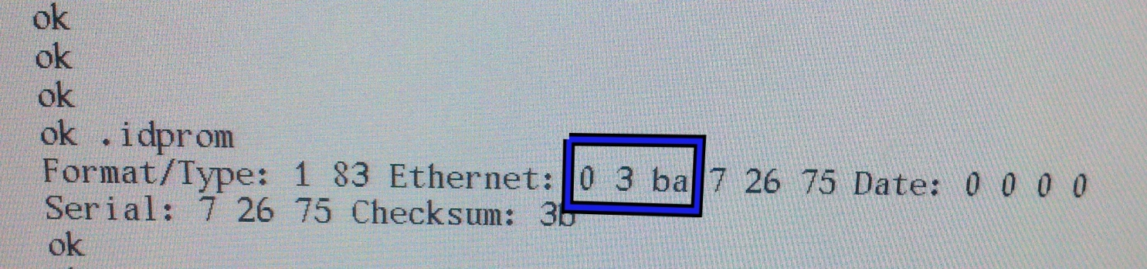

The numbers you need from .idprom output.
>>>>>>insert some techno babble here about how to bail your butt out of the serious crap you are in <<<<<<<<<<<<<<<<<<<<<<<<<<<< <<<<<<<<<<<<<<<<<<<<<<<<<<<<<<<<<<<<<<<<<<<<<<<<<<<<<<<<<<<<
Something like…..DO NOT DO THIS YET DRAFT DRAFT

At ok prompt type:
f idprom@ 1 xor f mkp
M M MM XX XX XX ZZZZZZ mkpl (ex: 0 3 ba 7 27 23 072723 mkpl )
[Ctrl][D][R] (hold Ctrl key, tap D, tap R, release Ctrl key)
.idprom [enter]
banner [enter] (No error?)
power-off

but DO NOT DO THIS YET…..DRAFT>>>>DRAFT

If system boots: verify network functionality
Set system time
Initialize NVRAM: TM Manager, NVRAM Check ,Initialize
Scan
Service Backup

If system still does not boot, you are screwed. I hear Applebee’s makes a nice margarita.

Section 6 Software Procedures

Database Reset

Purpose :
Prior to reloading software or changing hard drives, this process can be used to reset the databases. In most cases, this will take care of software problems.

BEFORE beginning, perform protocol and service backups

Under the preference tab, note the name of the system in the bottom right-hand corner, this will have to be added later.

Shut the system down and bring it back up normally. When you get the “please wait while loading” page, look for the chicklet in the upper right-hand corner. Double-click the chicklet, a white bbox
appears, press CRTL-C

You MUST do this in a hurry or you will not be able to abort the boot sequence.

Once the boot sequence has been stopped, press CTRL-ALT-F12. A white box will appear. Type clear_dbs, press enter. A bunch of stuff about Bulk will appear, let this run. At times, it will look like nothing is happening………..BE PATIENT.

Wait for the “Shut down safe and complete” line to appear. This takes about 10 minutes. If you wait more than 20 minutes and this does NOT appear, you missed stopping the boot sequence.

Press CTRL-ALT-F12. Type su shutd. The system will shut down. Bring system up as normal, reload protocol backup. Check system name under preferences. It is NOT necessary to reload service backup.

Done

Section 7 Software Procedures

Changing Modality ID

Purpose:
Setting up a new HD for use on a system.

Boot the system. Once the system is fully booted, press CTRL – ALT – F12. This will bring up the XTERM window, for command entry.

In the XTERM window, type sysinit, and hit Enter. The System Initialize Tool window will appear. In this window, you will see a Serial No. aea, with 5 numbers in it. You are ONLY to change the final three numbers to match the three numbers of the Modality you are at(ex., modality is H066, number shows 17201, change number in window to 17066).

Leave the Debug Mode choice as it is.

Click OK at the bottom of window, and the window will close. Type exit in the XTERM window and hit Enter.

Reboot system.

Verify System ID and Operation.

Done.

HARDWARE PROCEDURES

Section 4 Hardware Procedures

CHANGING OF THE 1 PSI VALVE

Periodically, problems can arise with the Altaire’s 1 PSI Valve, the system’s first line of defense against helium pressure build up. In those cases, the valve will need to be replaced. This procedure is very detail oriented, but easy to perform if followed correctly. Read procedure completely, first, before performing work.

Tools and Materials required:

Two open end, or adjustable wrenches, capable of fitting the 1 PSI Valve
Pair of cold weather gloves
Teflon tape
Baby cam unit (optional)

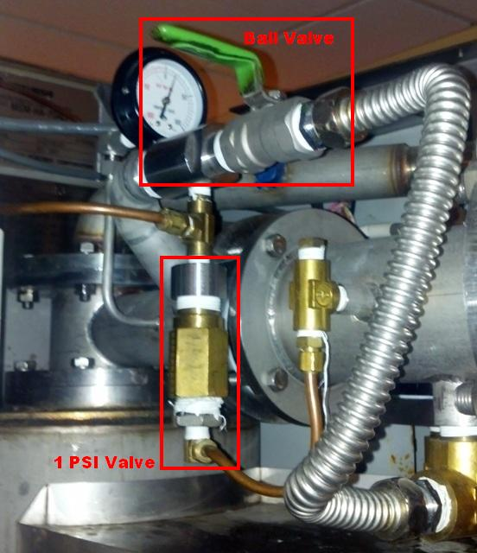

- Check your reading at the CCU unit. The 1 PSI Valve is set to relieve pressure at a reading above 700. Document this reading. Set up Baby cam unit if you have one, to view the CCU pressure from the Gantry room. If you do not have this unit, proceed to Step 2.

2) Remove the small copper tube at the bottom of the 1 PSI Valve by removing the compression nuts at both ends. Set this tube aside for re-installation later.
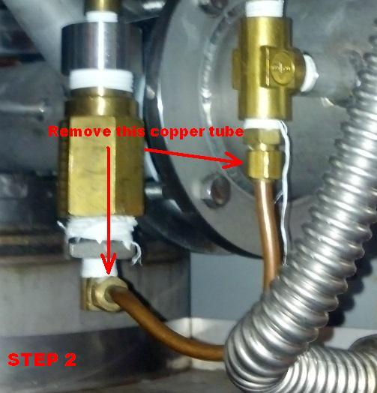

3) The 1 PSI Valve CAN NOT be replaced until you have relieved the helium pressure down to a 300 reading at the CCU. To do this, you will open the ball valve to release some of the helium, located next to the 1 PSI Valve. NOTE: You must NEVER turn this valve past a 45 degree angle. Doing so will release to much helium, to quickly, and can have disastrous results, a.k.a., quenching the magnet. To start you will just crack the valve slightly, until you hear a slight hiss of gas escaping.
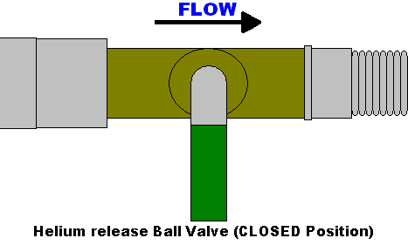
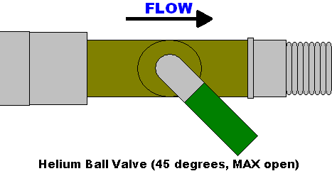
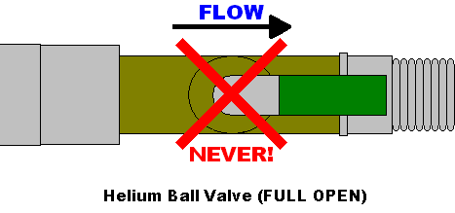

4) Once you have started a slow flow of helium, check your CCU reading. If you do not have a Baby cam unit, you will need to directly go to the CCU unit and visually check this number. It should be decreasing. A good tempo for this decrease is 1 per second.

5) If it is decreasing faster than this, close the ball valve a bit. If it is decreasing slower than this, open the valve slightly, remembering to NEVER go past 45 degrees on the ball valve! You will need to constantly monitor the flow of helium on the CCU unit, going back and forth if no Baby cam unit is available.

6) If you have not already, put on your cold weather gloves. Once the CCU pressure has reached 300, you may remove the 1 PSI Valve, but very carefully. You may now close the ball valve. NOTE: Before removing the 1 PSI Valve, be sure to have your replacement within reach, for a quick swap. This includes already having Teflon tape on the valve threads and ready to go into place.

7) Remove the old 1 PSI Valve, and immediately put your thumb or finger over the open hole on the machine pipe that the valve came out of.

8) Grab the new valve and remove your thumb or finger, and quickly, and smoothly, screw the new valve into place by hand. NOTE: The pipe works on the top of the machine and in your working area will have gotten quite cold, and will have frosted over. This is normal, but you need to be aware of it.

9) Tighten the valve in with your wrenches, be careful not to over tighten, but that there are no leaks at the connection.

10) Double check that your ball valve is closed. Go back and check the CCU pressure. It should be rising again. Document this number.

11) Re-attach the lower copper line to the new 1 PSI Valve.

Check the CCU number regularly over the next 30 minutes to an hour. It should be rising, even if slowly. If it is dropping, double check that your ball valve is closed and that the 1 PSI Valve is not leaking. No change can occur, and is not necessarily cause for alarm.
Congratulations, you have swapped out the 1 PSI Valve.

NOTES:

1) Safety is key, both for you and the machine. Make sure of your surroundings and the procedure before attempting this procedure.
2) Be CERTAIN to install the 1 PSI Valve correctly, as in the above photos. The threads from the brass compression fitting are the same as the stainless ones on top of the 1 PSI Valve. Remember, if it is upside down, it will not work!

3) NEVER put Teflon tape on a brass compression fitting.

4) If you are stumped, call for back-up. Your fellow Field Service Engineers are more than happy to assist. Pride can cause more mistakes at a job site than anything else: you have the resources, use them!

Section 7 Hardware Procedures

REPLACING O2 SENSOR

- Check your new O2 sensor to make sure it has not expired.

- Locate O2 sensor in scan room.

- You may need a ladder to get to it

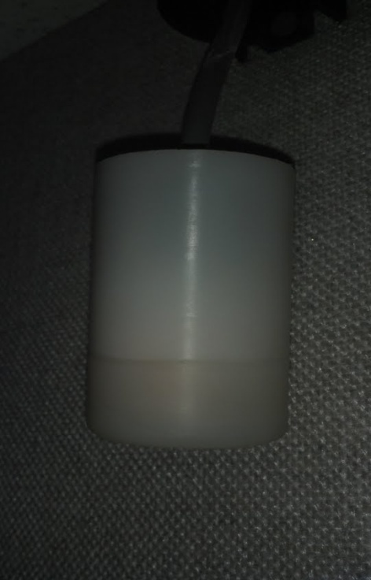

- Unscrew the bottom of the plastic cover to remove old O2 sensor.
- Be sure to put the new O2 sensor in the same way you took out the old one.

- You have now replaced the O2 sensor.
- Be sure the O2 sense box is on and programmed between 21.0 – 23.0.
- To programmed box press Span then up or down on the arrows to change numbers then Span again and your finished.

Section 7 Hardware Procedures

TUNING TRANSMITTER PROCEDURE

- Staging and preparing for tuning.

- Tune the frequency of your Via Bravo to the resonance frequency of the magnet
- Remove back gantry, top transmitter, and bottom transmitter covers
- Open TM manager > Coil Adjustments > Decoupling then turn on both decoupling

- Specs for tuning transmitter

- Lower Coil
  - Impedance – 60Ω ± 5Ω
- Upper Coil
  - Impedance – 50Ω ± 5Ω
- Phase for upper and lower transmitter
  - 0° ± 5°

- Adjusting Impedance

- Connect capacitor to transmitter where screws are located.
- 10pF = 1Ω
- Decreasing capacitance increases impedance and vice versa

- Pictured below will show you where the trimmer capacitors are and where to hook up your impedance meter (Via Bravo).
- Lower trimmer capacitors – 4CN and 6CN
- Upper trimmer capacitors – 3CN and 5CN

*Insert Picture Here*

Connector No.  on the back side of gantry | Trimmer capacitor to be adjusted (in frontal view of gantry) | Impedance adjustment position (in frontal view of gantry)
3CN | Upper Left | Upper right back
4CN | Lower Left | Lower right back
5CN | Upper Right | Upper left back
6CN | Lower Right | Lower left back

Tuning transmitter

- When tuning the upper transmitter be sure the bottom decoupling wire (90CN) is unplugged and decoupling is turned on. (Refer to step 1)
- When tuning the lower transmitter be sure the upper decoupling wire (89CN) is unplugged and decoupling is turned on. (Refer to step 1)
- Decoupling wire pictured. White connector with red and white wires coming off of it.

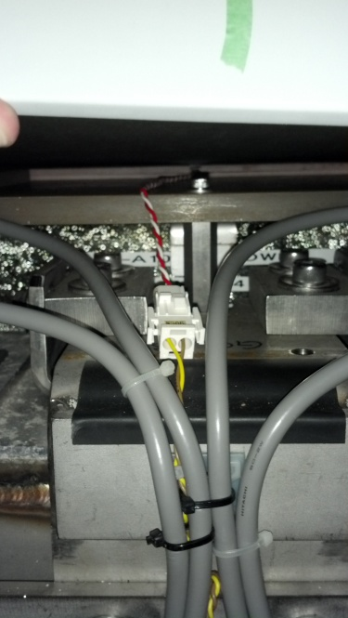

- When tuning coil, connect your Via Bravo to the BNC connection at the back of the transmitter looking into the coil. (Refer to 2nd picture to clarify which trimming capacitor to adjust for both sides of the top and bottom transmitter coil)

EQUIPMENT MANUALS

APPENDIX: EQUIPMENT MANUALS

VIA BRAVO SETUP

Via Bravo Reset
Turn Via Bravo ON while holding the ENTER button down for three seconds.

Selecting Proper X and Y Axis Measurement

- Select F1 then F3
- As follows is the correct set up for the X and Y PLOT measurements
CHOOSE 1ST PLOT : RESISTANCE
CHOOSE 2ND PLOT : ANGLE
CHOOSE RLC MODEL : SERIES
PLOT WIDTH: 80 POINTS
BIG FREQ DISPLAY : OFF
NOISE FILTER : OFF

- If any of these are different move your cursor to the one that is incorrect and hit ENTER

- Proceed to select the correct option in the list of measurements and hit ENTER

Selecting Proper X and Y Axis Values

- Select F1 then F4

- Select PLOT 1 RESIS. SCALES :500

- The last number should read 500
- IF the value is different from 500 move the cursor to 500 and hit ENTER

- Repeat Step 1

- Select PLOT 2 θ SCALE : 180

- The last number should read 180
- If the value is different from 180 move the cursor to -90 TO +90

- Repeat Step 1

- Select X AXIS LABLE : -DF FC +DF

- Be sure -DF FC +DF is selected
- At the bottom right and left of your graph should read +400k and -400k respectively
- If these values are different use the WIDTH ARROWS to adjust

RADIO SHACK AUTODIALER MANUAL(WHITE)

